Life Chart

Life charting provides a timeline and sequence of events in one’s life that relate to bipolar disorder. The exercise helps to identify causes and effects, triggers, and effects of treatment. It focuses on periods of depression, mania, but also periods of feeling “normal”

INSTRUCTIONS:

- Draw in episodes of depression and mania: lifetime OR past last 1-2 years
- Add periods of substance use
- List all major life events
- List treatments

EXAMPLE:
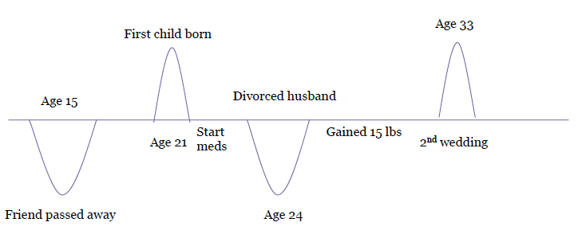
Source: Dr. Noah Lazar

YOUR TURN:
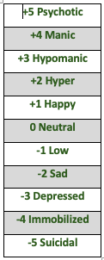

Learning from Life Chart

Situation | Mania | Depression
Illness
Life Changes
Losses
Partying
Relationship Events
Schedule changes
Seasonal
Vacations
Weather

Example:
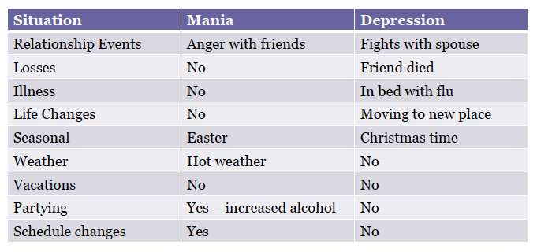
Source: Dr. Noah Lazar

