Mood – Symptom Links

Situation | During Manic Period | During Depressive Period | OK
Mood |  |  | Balanced.
Self-perception
Social activities
Sleep
Concentration
Creativity
Seasonal
Vacations
Weather

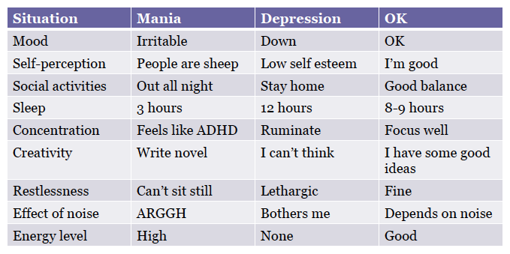
Source: Dr. Noah Lazar

DISCUSSION WITH THERAPIST
What are the events and situations that trigger a shift in mood?
How do I know when I’m first getting depressed?
How do I know when I’m first getting manic?

