Thought Record for Manic Thinking Styles

Situation | Mood  0-100% | Hot Thought | Evidence that supports hot thought | Evidence that does not support hot thought | Alternative thought  (Rate extent to which you believe) | Revisit  Mood  0-100%
Who?  What?  Where? | Describe mood in one word.  Rate intensity. | Mania-induced thinking:  Name the big idea; the impulsive decision; or the thing you fear will happen.
 |  |  |  |  | Plan of Action

Examples of Manic Thinking Styles
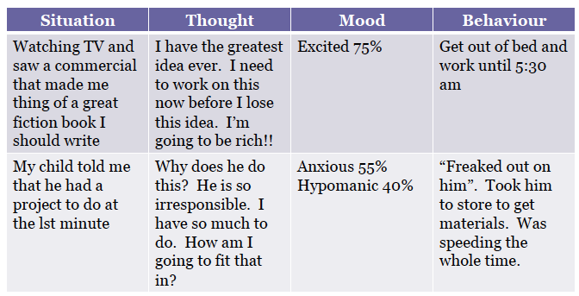
Source: Dr. Noah Lazar

