

Graded Task Assignment

*for anxiety and depression*

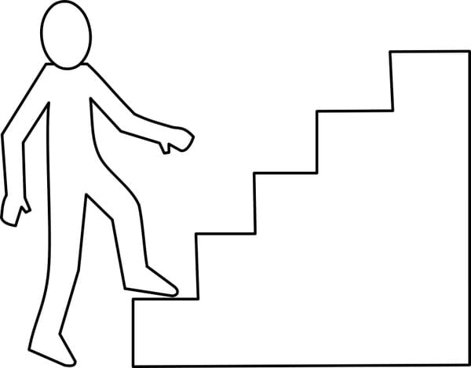

Graded Task

Distress =3-5

Graded Task

Distress = 7-9

Graded Task

Distress = 5-7

Ultimate Goal

Distress = 9-10

Graded Task

Distress = 0-3